Project Title: Insurance Claims Risk Analysis
Tajhjani Brooks
10th August 2026
An investigation of the factors associated with insurance claim frequency and severity


Problem Identification
Background
Insurance plays a significant role in protecting individuals and businesses from the financial consequences of unforeseen events. Insurance is a financial agreement between an individual or organisation and an insurance company, in which the policyholder pays a predetermined amount of money, known as a premium, in exchange for financial protection against specified risks. If a covered event occurs, such as an accident, property damage or other insured loss, the policyholder can submit a claim to request compensation, subject to the terms and conditions of their policy.
Insurance companies use a combination of historical data, statistical analysis and actuarial techniques to assess risk and estimate potential future claims. This allows insurers to determine appropriate premiums and ensure they have sufficient funds to cover claims, operating costs and other financial obligations while remaining competitive.
Insurance claims can vary considerably in both frequency and severity. Claim frequency refers to how often claims occur, while claim severity refers to the financial cost associated with individual claims. Analysing historical claims data can therefore help insurers identify patterns, understand factors associated with higher-risk claims and make more informed decisions.
Problem
Insurance companies handle large volumes of claims containing information about policyholder characteristics, policy details, claim types and claim amounts. Analysing these large datasets manually can make it difficult to identify patterns and relationships that may contribute to increased claim frequency, severity or overall risk.
Relying heavily on manual analysis can also be time-consuming and may increase the possibility of human error when dealing with large datasets. Inaccurate risk assessment could result in insurers underestimating potential losses, potentially leading to financial losses, or overestimating risk, which could result in less competitive premiums and the loss of customers.
Therefore, there is a need for a data-driven approach that can efficiently analyse historical claims data, identify factors associated with claim risk and cost, and present these findings in a clear and accessible way.
Why a Solution Is Needed
A data-driven solution could assist insurers in identifying patterns and factors associated with higher claim frequency and severity more efficiently. Analysing historical claims data could help insurers better understand the characteristics associated with increased risk and support more informed decision-making.
The solution could be particularly beneficial for insurance companies handling large volumes of claims, as automated analysis could reduce the time required to identify trends and allow important information to be presented more efficiently. This could support insurers in improving risk assessment, allocating resources effectively and maintaining financially sustainable insurance policies.
Next Steps
The next step is to conduct secondary research into insurance risk assessment, claims management and the factors that influence claim frequency and severity. This will involve reviewing reliable sources such as academic research, industry reports, books and relevant financial and insurance publications.
I would then investigate publicly available insurance claims datasets to determine which variables would be most suitable for analysis and identify any limitations within the available data. I would also research appropriate statistical and machine learning techniques that could be used to identify patterns and potentially predict claim risk or claim costs.
Finally, I would design graphical displays and reports that clearly communicate the findings, allowing potential stakeholders to understand the identified patterns and the purpose and effectiveness of the proposed solution.

Research
To develop an insurance risk claim analysis system, there needs to be a broad understanding of insurance, risk assessment, claims management, statistical analysis, data visualization and machine learning. I will highlight different terms and processes that are needed to enhance my understanding of how insurance companies analyse historical claims data and assess potential future risks.

Risk Assessment terms
Insurance risk: refers to the potential for a loss or adverse event that an insurance company agrees to cover under a policy. These risks, such as accidents, natural disasters, or theft, can lead to financial loss, and insurance provides protection against them in exchange for regular premium payments.
Claim frequency refers to the number of insurance claims filed within a specific period relative to the insured population, and it is crucial for assessing risk and determining insurance premiums. High claim frequency indicates a higher likelihood of policyholders filing claims, which can lead to increased costs for insurance companies.
Risk factors are characteristics that may influence the likelihood or cost of an insurance claim. Depending on the type of insurance, these could include age, location, vehicle type, policy type, previous claims and other policyholder characteristics.

Insurance terms
Insurance: is a legal contract (insurance policy) agreed upon between the two parties, namely the insurance firm (also known as the insurer) and the individual or group (known as insured). It is a method that spreads the loss likely to be caused by an unknown occurrence among several people who are exposed to it and plan to protect themselves against it.
Insurance premiums: are regular payments made by policyholders to keep their insurance coverage active, covering a variety of risks and potential losses.
An insurance claim is a request made by a policyholder to their insurance company asking for payment or services after a covered event, such as an accident, theft, natural disaster, or medical procedure.
Claims Data
Historical Claims Data:
Historical claims data contains information about previous insurance claims. Variables could include policyholder characteristics, policy information, claim type, claim amount and whether a claim occurred.
Data Cleaning:
Data cleaning, also called data cleansing or data scrubbing, is a critical step in data preprocessing that prepares raw datasets for analysis, reporting, or machine learning tasks. Its main goal is to improve data quality by addressing issues such as missing values, duplicates, incorrect data types, outliers, inconsistencies, and irrelevant information, ensuring that the data is reliable and actionable for decision-making or predictive modelling
Data Processing:
Data processing involves transforming raw claims data into a suitable format for statistical analysis and machine learning. This may include selecting relevant variables, converting categorical information into numerical values and creating new variables where appropriate.

Statistical Analysis
Mean:
The mean is calculated by adding all values and dividing the result by the number of observations. In insurance analysis, the mean could be used to calculate the average claim amount or average age of policyholders.
Median:
The median is the middle value when a dataset is arranged in ascending order. It can be particularly useful when analysing claim amounts because a small number of extremely expensive claims can significantly affect the mean.
Variance:
Variance measures how spread out values are around the mean. In insurance, it could be used to examine how much claim amounts vary from the average claim.
Standard Deviation:
Standard deviation measures the typical amount by which values differ from the mean. A higher standard deviation in claim amounts would indicate greater variation in claim costs.
Probability or chance is how likely something is to happen. If something has a low probability, it is unlikely to happen. If something has a high probability, it is likely to happen.
Where probability can be used estimate of the proportion of policies that result in a claim within a particular dataset.

The probability for this can be used examine whether certain characteristics are associated with a higher possibility of making a claim

Data Visualization
Graphs and Charts
Data visualisation allows large datasets to be represented in a format that is easier to understand. The system could use graphs to display information such as:
- Distribution of claim amounts
- Number of claims by policy type
- Average claim amount by age group
- Claim frequency by location
- Relationship between policy characteristics and claim costs
Bar Charts:
Bar charts can compare claim frequency or average claim amounts between different categories, such as policy types.

Regression Models
Regression models can be used to investigate relationships between variables and potentially predict numerical outcomes.
A simple linear regression model can be represented as:
Where:
- Y = dependent variable, such as predicted claim amount
- x = independent variable, such as policyholder age
- m = slope of the regression line
- b = y-intercept
A regression model could investigate whether there is a relationship between a policyholder's characteristics and the expected value of an insurance claim.
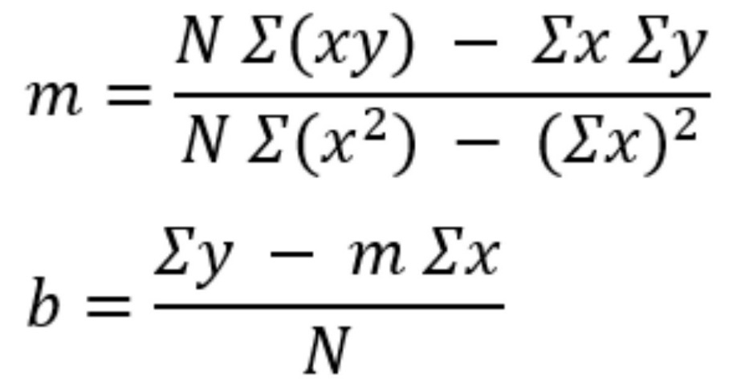

Machine Learning
Machine learning can be used to identify patterns within historical insurance data and make predictions based on those patterns.
Potential models for this project include:
Linear Regression:
Could be used to predict a continuous value, such as claim cost.
Decision Tree:
Can classify or predict outcomes by creating a series of decision rules based on the input variables. This could be useful for identifying factors associated with higher-risk claims.
Random Forest:
Combines multiple decision trees to produce a more robust prediction. It can also provide information about which variables are most influential in making predictions.
Logistic Regression:
Could be used to predict a binary outcome, such as whether a policy is likely to result in a claim.
Model Evaluation
It is important to evaluate the performance of machine learning models rather than assuming that a prediction is accurate.
For regression models, evaluation methods could include:
Mean Squared Error (MSE):
MSE measures the average squared difference between the actual and predicted values. A lower MSE generally indicates that the model's predictions are closer to the actual values.
Mean Absolute Error (MAE):
MAE measures the average absolute difference between predicted and actual values.
For classification models, metrics such as accuracy, precision, recall and F1-score could be investigated.

Objective
The purpose of this project is to predict whether an insurance claim is fraudulent, based on characteristics recorded in the dataset. The program will identify the characteristics most significantly associated with fraud and use them to train multiple machine learning models including Logistic Regression and Random Forest to compare which approach predicts fraud most effectively.
Statistical testing, such as chi-square tests and t-tests, will be used alongside the machine learning models to confirm whether the relationships identified are statistically significant, rather than relying on visual patterns alone. Comparing multiple models and validating findings statistically is intended to improve the overall reliability of the project's conclusions, rather than relying on a single method that could be misleading on its own.
The project will use a large, realistic dataset (1,000 claims) to demonstrate that the approach is effective and efficient at a scale relevant to real insurers, giving anyone interested a suitable sense of how it could be applied to their own claims data.
To make the findings accessible, the project will include clear charts alongside brief descriptions of what each chart shows, so that someone without a background in insurance or data analysis can still understand the key findings.
Finally, since real-world data is rarely clean, the project will include a dedicated data-cleaning stage to identify and resolve issues such as missing values and inconsistent formatting before any analysis takes place. This ensures the results are based on reliable, properly prepared data, rather than being distorted by errors in the original spreadsheet.

Success Criteria:
Success Criteria
1. Accuracy and consistency of insurance claim fraud prediction
Criteria: The model should correctly predict whether a claim is fraudulent at least 80% of the time. This means that out of 1,000 claims, at least 800 predictions must match the actual fraud outcome.
Justification:
High Impact of Errors: High accuracy is critical for the program's reliability. Inaccurate predictions could lead to wasted resources, for example, investigating claims unnecessarily, or failing to flag real fraud.
Reliability: Consistent accuracy between predicted and actual fraud outcomes builds trust in the program for anyone considering using it for their own analysis.
2. Identify the most important characteristics that predict fraud
Criteria: The program should be able to identify which characteristics are most strongly associated with fraudulent claims.
Justification:
Practical Value: Identifying the characteristics most associated with fraud makes it easier to understand why a claim might be suspicious, based on patterns seen in past fraudulent claims.
3. Ability to process large amounts of data
Criteria: The program should be able to process and analyse a large dataset (at least 1,000 claims) without errors, using multiple types of information such as claim amount, location, vehicle type, policy type, and customer tenure.
Justification:
Real-World Practicality: Handling a large, varied dataset efficiently demonstrates that the program is genuinely useful in practice, since real insurers deal with far more than a handful of records at a time.
4. Intuitive graphical user interface
Criteria: The GUI should include clear navigation (such as buttons), charts, and short descriptions explaining what each chart shows, to keep the software simple and easy to use.
Justification:
- Ease of Use: Anyone with limited technical understanding should be able to interpret the charts and read a description of why each one matters.
- Visual Insight: Charts allow the data to be understood visually, without requiring the viewer to analyse raw numbers or have specialist knowledge of insurance.

Design

Data Source and Justification
The dataset used in this project is 'insurance_claims.csv', published on Mendeley Data by Aqqad (2023). It contains 1,000 individual motor insurance claim records, each described by around 40 variables covering the policyholder (such as age and months as a customer), the policy itself (such as premium and deductible), and the incident (such as severity, type, and claim amount). The key variable is fraud_reported, which records whether each claim was ultimately found to be fraudulent following investigation. To protect privacy, personal identifiers were anonymised and replaced with unique IDs before the dataset was published.

Reason why I picked this dataset:
I chose this dataset for a few reasons. Firstly, it has1,000 claims which meets one of my success criteria, which required the program to work with a large dataset. A larger dataset also helps ensure the program isn't tailored to one specific, frequent type of claim, but can instead work across multiple claim types with different characteristics. Secondly, the dataset includes a wide range of variables, which I could use to help identify which characteristics have a significant, positive association with fraud

Script Structure
01 – Data Understanding: This script loads the raw spreadsheet and prints key information about it — such as its shape, column names, data types, and missing values to build an initial understanding of the dataset before any changes are made.
02 – Data Cleaning: This script prepares the raw dataset so it can be used reliably. Missing values in categorical columns are filled with "Unknown" rather than removed, date columns are converted from plain text into a proper date format, and invalid negative values (such as customer tenure) are corrected to zero.
03 – Exploratory Data Analysis (EDA): This script analyses the cleaned data visually. It produces charts comparing different characteristics such as incident severity, insured hobbies, and time of day against fraud rate, to identify patterns worth investigating further.
04 – Statistics: This script applies statistical testing to determine whether the patterns found in the EDA stage are genuinely significant, rather than due to chance. This includes a correlation matrix, chi-square tests, and t-tests.
05 – Machine Learning Model: This script uses the significant characteristics identified in the previous stages to train machine learning models (Logistic Regression and Random Forest) that predict whether a claim is fraudulent. The performance of each model is compared, so the more reliable model can be identified.
06 – GUI Dashboard: This script provides an interactive graphical interface where the user can view every chart produced throughout the project, each with a brief description explaining what it shows and why it matters.

Flowcharts
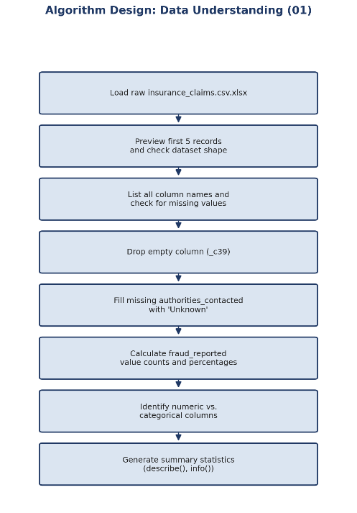
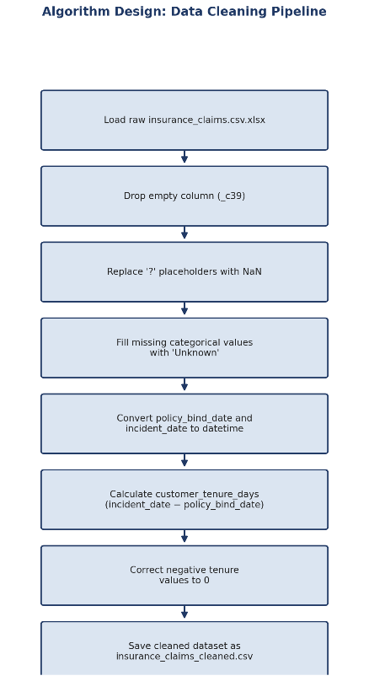

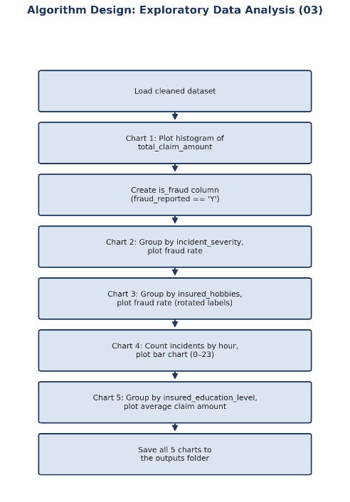
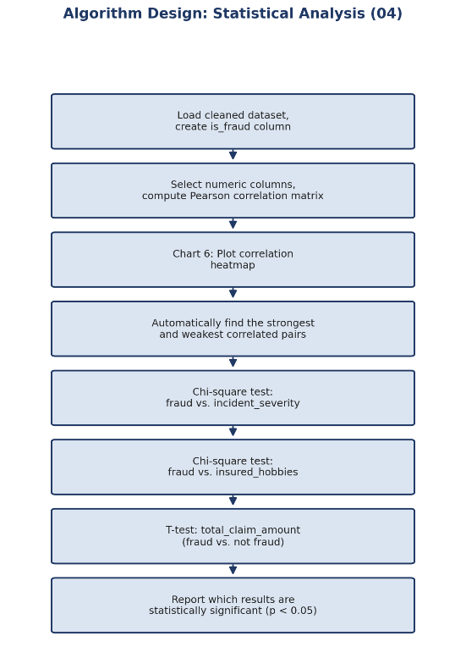
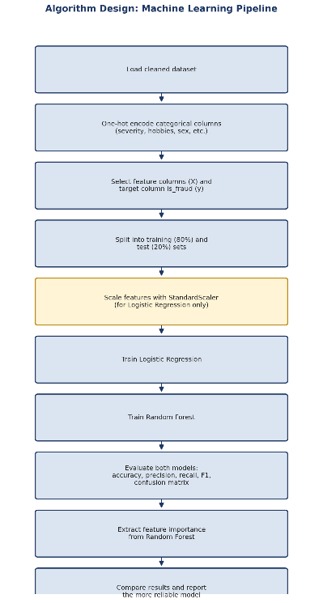
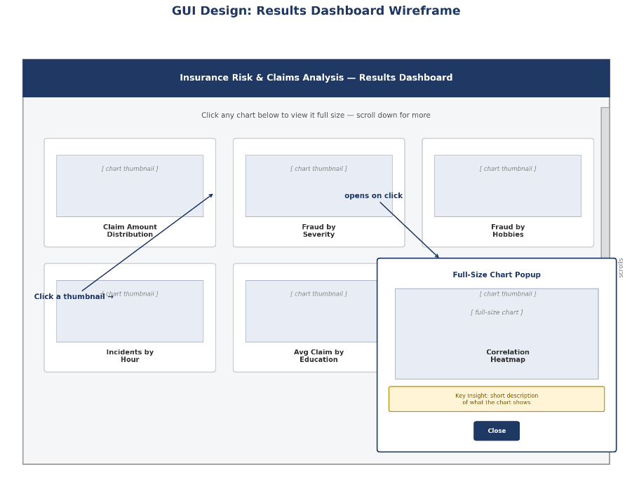

Technical Solution
01 Data Understanding
Prior to undertaking any cleaning or analytical procedures, the raw dataset underwent initial exploration to comprehend its structural composition and detect any issues requiring remediation. The dataset contains 1,000 insurance claims, each described by 40 columns covering the policyholder (such as age and months as a customer), the policy (such as premium and deductible), and the incident (such as severity, type, and claim amount).
This initial exploration revealed two issues that needed to be addressed before analysis could begin:
- An empty column, _c39, which contained no data and needed to be removed.
- Missing values in the authorities_contacted column, which needed to be handled before the data could be used reliably.
- Column which contained negative values which needed to be set to zero

The dataset underwent examination to determine which columns contained numeric data (including age and total_claim_amount) and which contained categorical data (including incident_severity and insured_hobbies), as this classification would prove significant during subsequent data preparation phases for statistical analysis and machine learning applications.
02 Data Cleaning
After Data Understanding, cleaning was the next step. This script prepared the raw dataset so it could be used reliably in statistical analysis and machine learning.
Several columns used "?" instead of leaving a cell blank when information was missing. Since pandas doesn't recognise "?" as a missing value on its own, these were first replaced with proper missing values (NaN), then filled with "Unknown" rather than removed. this avoided losing the rest of that claim's information for the sake of one missing field.
Date columns (policy_bind_date and incident_date) were converted from plain text into a proper date format, allowing date-based calculations to be performed. This enabled a new feature, customer_tenure_days, to be engineered which is the number of days between a customer starting their policy and the incident occurring.
While checking this new feature, one row was found with a negative tenure value, meaning the incident was recorded as happening before the policy even started. This was identified as a data error rather than a real event, and corrected to zero rather than deleting the row, to preserve the rest of that claim's information.

03 Exploratory Data Analysis
After Data Cleaning, Exploratory Data Analysis was the next step. This script used the cleaned dataset so that every chart would reflect accurate, corrected information. The cleaned dataset was loaded by setting a file_name variable pointing to the cleaned CSV file created in the previous stage.
Chart 1 — Distribution of Total Claim Amount
This chart shows how claim amounts are spread across all 1,000 claims, with total claim amount on the x-axis and the number of claims on the y-axis.
Finding: The distribution shows two distinct groups, a spike of low-value claims around £5,000-8,000, and a broader peak around £55,000-65,000. This suggests two different types of claims exist within the dataset, worth investigating further.
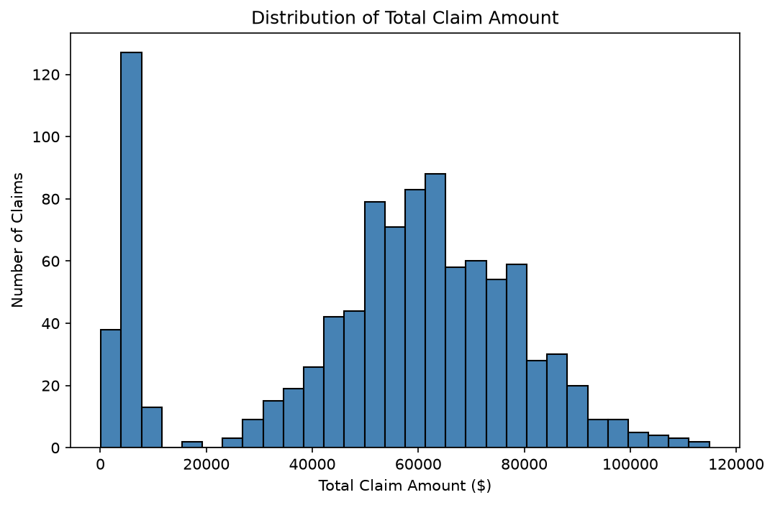
Chart 2 — Fraud Rate by Incident Severity
To find the fraud rate for each severity level, the data was grouped by incident_severity, then the average of is_fraud was calculated for each group. Since is_fraud is a True/False column, averaging it gives the proportion of claims that are True, which is exactly the fraud rate. This was done using the .mean() function.
Finding: Major Damage claims were fraudulent around 60% of the time, roughly five times higher than every other severity level (all under 13%). This is the strongest single pattern found in the EDA stage.
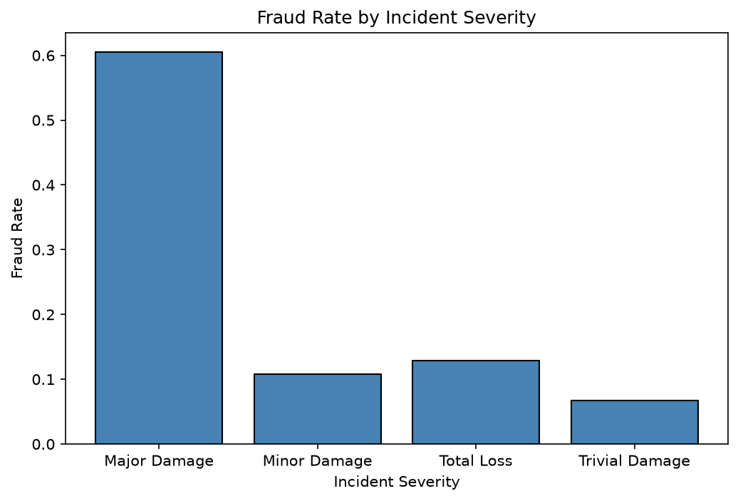
Chart 3 — Fraud Rate by Insured Hobbies
A similar process to Chart 2 was used, grouping by insured_hobbies instead. Since there were 20 different hobbies, the default chart size wasn't wide enough to display all the labels clearly. plt.tight_layout() was used to automatically shrink the plot area, so nothing was cut off, and plt.xticks(rotation=45, ha='right') rotated the labels so they didn't overlap.
Finding: Chess (83%) and Cross-fit (74%) stood out sharply above every other hobby, which mostly sat between 9-30%. This is a striking pattern, though not necessarily a realistic real-world cause of fraud — more likely a quirk of how this dataset was generated, and worth flagging as a limitation later.
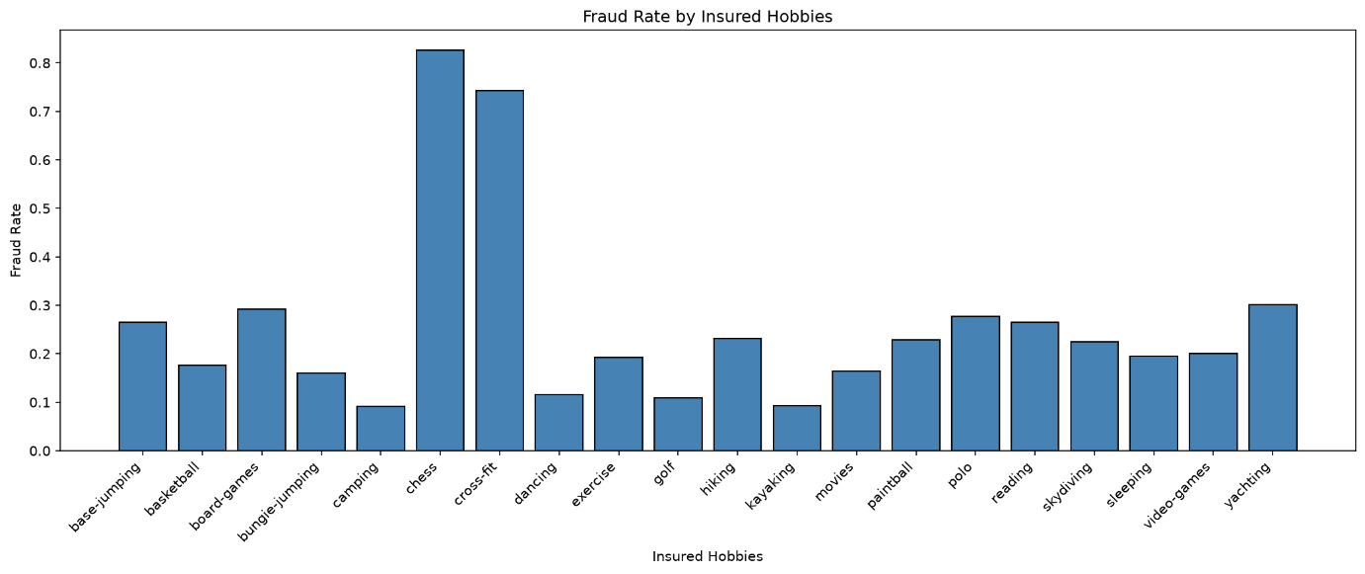
Chart 4 — Incidents by Hour of the Day
data['incident_hour_of_the_day'].value_counts().sort_index() was used to count how many claims occurred in each hour (0-23). .value_counts() counted the claims per hour, and .sort_index() arranged them in hour order rather than by size, so the chart reads as a proper 24-hour timeline. As with Chart 3, plt.xticks() and plt.tight_layout() were used to fit all 24 hour labels clearly.
Finding: Incidents were not evenly spread across the day — noticeable spikes occurred around midnight, 3am, and 5pm, with quieter periods around 1-2am and 11am.
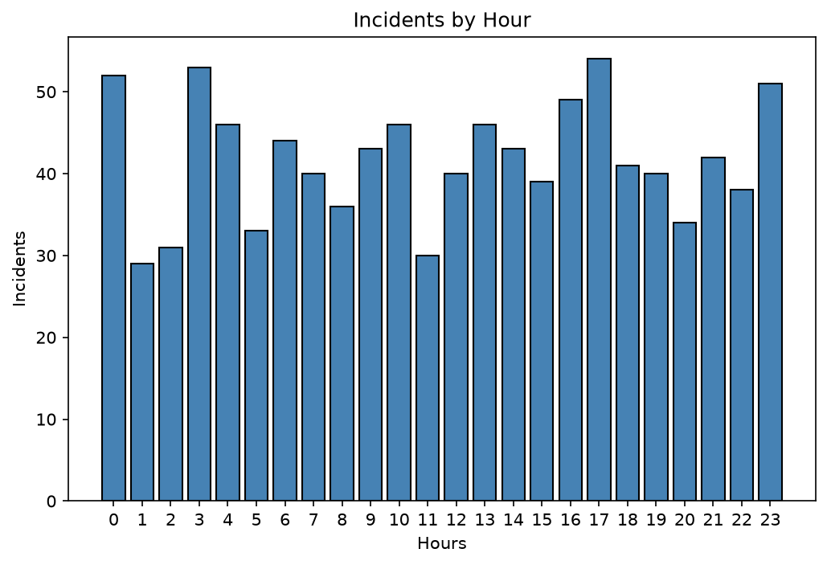
Chart 5 — Average Claim Amount by Insured Education Level
Similar to Charts 2 and 3, the .mean() function was used, this time grouping by insured_education_level and averaging total_claim_amount for each group — a standard numerical average, rather than a True/False proportion.
Finding: Claim amounts rose mildly with education level, from around £49,000 (Associate) to around £55,000 (PhD/MD) — an increase of roughly 13%, a much smaller effect than severity or hobbies.
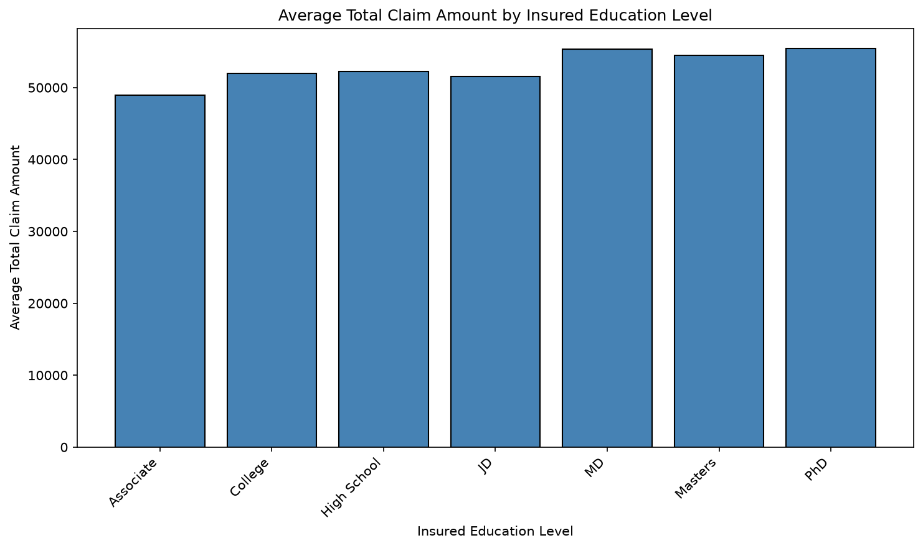
What I learned from this stage
Chart formatting needs to adapt to how much data is being displayed. A chart with only a few short category labels (like Chart 2's four severity levels) works fine with matplotlib's default settings. However, charts with many or long labels (like Chart 3's 20 hobbies or Chart 4's 24 hours) require plt.tight_layout() and plt.xticks(rotation=...) to remain readable, otherwise labels overlap or get cut off.

Statistics (04)
After Exploratory Data Analysis, Statistics was the next step. This script used the cleaned dataset to ensure every statistical test was based on accurate, corrected information. The cleaned dataset was loaded by setting a file_name variable pointing to the cleaned CSV file created in the previous stage.
This section was primarily used to identify correlations between numeric characteristics, and to statistically confirm whether patterns noticed during EDA were genuinely significant, rather than relying on charts alone. Statistical testing methods used included chi-square tests and t-tests. A chi-square test checks whether two categorical variables are genuinely related, or whether any pattern between them could just be due to chance. A t-test checks whether the average of a number is genuinely different between two groups, rather than the difference being down to chance.
Chart 6 — Correlation Heatmap
This chart shows the correlation between every pair of numeric columns in the dataset. Since a correlation matrix only makes sense on numeric columns, the first step was to filter out categorical columns like incident_severity, keeping only columns with a numeric data type. Next, the correlation between each pair of numeric columns was calculated using the Pearson correlation function, .corr(method='pearson'). The result was then plotted as a heatmap, with settings adjusted so all 19 columns remained readable.
Finding: total_claim_amount and vehicle_claim had the strongest relationship in the dataset (0.9828), while insured_zip and customer_tenure_days had the weakest (0.0001).
Chi-Square Test: Fraud vs. Incident Severity
This tested whether fraud and incident severity — two categorical variables — were genuinely related, or whether any pattern between them could be due to chance. First, is_fraud was created by checking where fraud_reported equals 'Y'. A contingency table was then built, and chi2_contingency(contingency_table) was used to calculate the chi-square statistic, degrees of freedom, p-value, and expected values. A p-value below 0.05 is the usual cutoff for statistical significance, meaning the relationship is very unlikely to be due to chance; a p-value above 0.05 would suggest the relationship is likely due to chance.
Findings: Chi-square statistic: 264.2373, Degrees of freedom: 3, p-value: 5.447033547673865e-57
Result: Statistically significant relationship between fraud and incident severity.
Chi-Square Test: Fraud vs. Insured Hobbies
This followed the exact same process but grouped by insured_hobbies instead of incident_severity.
Findings: Chi-square statistic: 162.3154, Degrees of freedom: 19, p-value: 8.989147139882094e-25
Result: Statistically significant relationship between fraud and insured hobbies.
T-Test: Total Claim Amount (Fraud vs. Not Fraud)
A t-test checks whether the average total claim amount is genuinely different between fraud and non-fraud claims, rather than the difference being down to chance. First, the data was split into two groups: data['is_fraud'] = data['fraud_reported'] == 'Y' and data['not_fraud'] = data['fraud_reported'] == 'N'. From this, fraud_claims was set to data[data['is_fraud']]['total_claim_amount'], and not_fraud_claims to data[data['not_fraud']]['total_claim_amount'], making it simple to calculate the mean of each group using .mean(). The t-statistic and p-value were then calculated using ttest_ind(fraud_claims, not_fraud_claims). As with the chi-square tests, a p-value below 0.05 indicates a statistically significant difference, while a value above 0.05 would suggest no significant difference.
Findings: Average claim amount (fraud): £60,302.11, Average claim amount (not fraud): £50,288.61, t-statistic: 5.2406, p-value: 1.9529359591865884e-07
Result: Statistically significant difference in claim amount between fraud and non-fraud claims.

Machine Learning Model (05)
After the statistical tests confirmed that incident severity, insured hobbies, and claim amount were genuinely associated with fraud, the next step was to build a model that could use these characteristics to predict whether a new claim was likely to be fraudulent.
Encoding
Since machine learning models can only work with numbers, the categorical columns (such as incident_severity and insured_hobbies) first needed to be converted into a numeric form. This was done using one-hot encoding (pd.get_dummies()), which turns each category into its own 0/1 column — for example, incident_severity became four separate columns (incident_severity_Major Damage, incident_severity_Minor Damage, and so on), rather than one column with text in it. This expanded the dataset from 40 columns to 71.
Selecting Features and Target
Not every column was useful as a model input. Columns such as policy_number (just an ID), incident_location (too specific to generalise from), and the target itself (fraud_reported/is_fraud) were removed, leaving 47 genuine feature columns (X). The target variable, is_fraud, was set as y — the thing the model was actually trying to predict.
Splitting the Data
The dataset was split into a training set (80%, 800 claims) and a test set (20%, 200 claims) using train_test_split(), with random_state=42 to make the split reproducible. The training set is used to teach the model, while the test set is kept completely separate, used only afterwards to check how well the model performs on claims it has never seen — this prevents the model from simply "memorising" answers rather than learning a real pattern.
Scaling
Logistic Regression struggled to converge on the raw data, because features like total_claim_amount (in the tens of thousands) were on a completely different scale to the 0/1 encoded columns. StandardScaler was used to rescale every numeric feature to a similar range. Importantly, the scaler was fitted only on the training data, then applied to both the training and test sets — fitting it on the test data too would have leaked information from the test set into training, undermining the fairness of the evaluation. Random Forest did not need this step, since tree-based models split data using thresholds rather than distances, so it was trained on the original, unscaled data.
Training and Evaluating the Models
Two models were trained and compared: Logistic Regression and Random Forest. Beyond accuracy, precision, recall, and F1-score were also calculated, since accuracy alone can be misleading on an imbalanced dataset like this one (only around 25% of claims are fraud). Precision measures how many of the claims flagged as fraud were genuinely fraud; recall measures how many of the real fraud cases were actually caught; F1 balances the two.
Findings:
Metric | Logistic Regression | Random Forest
Accuracy | 83.00% | 79.00%
Precision | 0.684 | 0.614
Recall | 0.709 | 0.636
F1-score | 0.696 | 0.625
Logistic Regression outperformed Random Forest across every metric, not just accuracy. This suggests the relationship between these features and fraud is largely linear or additive, which favours a simpler model like Logistic Regression over a more complex one.
Confusion Matrices
The confusion matrix for each model shows exactly where predictions went right or wrong — correctly identified fraud, correctly cleared genuine claims, false alarms, and missed fraud cases. Logistic Regression correctly identified 127 genuine claims and 39 fraud cases out of 200, with 18 false alarms and 16 missed fraud cases.
Feature Importance
Random Forest can report which features it relied on most when making predictions. This doesn't just show how accurate the model is — it explains why it makes the predictions it does.
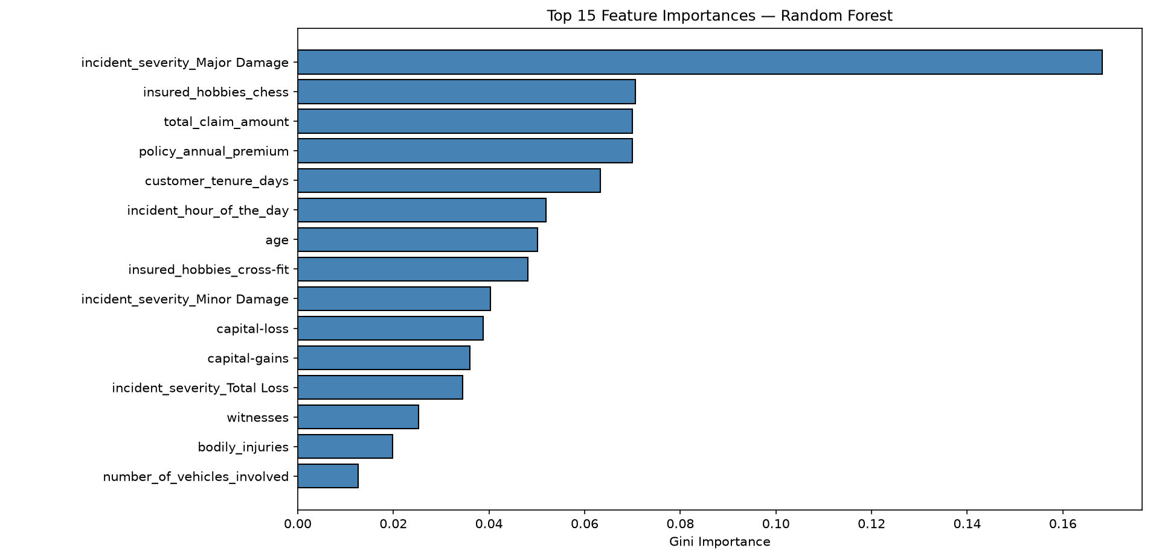
Finding: Incident severity (specifically "Major Damage") was by far the most important predictor, followed by the chess hobby outlier, total claim amount, and policy annual premium — the same factors identified independently through the earlier EDA and statistical testing stages. This consistency across three separate stages of the project (charts, statistical tests, and now the model) is a strong sign that these findings are genuine, not coincidental.

GUI (06)
The final script builds an interactive dashboard so every chart and finding from the project can be viewed in one place, without needing to run each script separately.
Loading the Charts Automatically
Rather than hardcoding each chart's filename, os.listdir('outputs') is used to automatically find every .png file saved by the earlier scripts. This means the dashboard doesn't need to be updated manually if a new chart is added later — it picks up anything saved into the outputs folder.
Displaying Charts as Thumbnails
Each chart is displayed as a small, consistently-sized thumbnail using the PIL library's .thumbnail() function, which resizes every image to fit within 320×200 pixels while keeping its proportions correct. This was used instead of tkinter's built-in image resizing, which only shrinks images by whole-number factors and produces inconsistent thumbnail sizes when charts have different original shapes.
Key Insight Panels
A dictionary, CHART_DESCRIPTIONS, stores a short, plain-English explanation of what each chart shows, keyed by its filename. This means a short preview appears under every thumbnail, and the full explanation appears in a highlighted panel when the chart is opened full size by making the findings accessible to someone without a technical background, not just the charts themselves.
Click to Enlarge
Clicking a thumbnail opens the full-size chart in a new window (Toplevel), alongside its Key Insight panel and a Close button. One technical detail was important here: inside the loop that creates each thumbnail, the click event is bound using lambda event, p=path, t=title: show_full_size(p, t). Without setting p=path and t=title this way, every thumbnail would incorrectly open the last chart in the folder when clicked, due to how Python loop variables behave inside a function defined within a loop.
Fitting the Chart to the Screen
When a chart is opened full size, its width and height are both checked against the screen's actual dimensions (winfo_screenwidth() and winfo_screenheight()), and scaled down if needed to whichever dimension needs to shrink more is used, so a chart never opens larger than the screen in either direction. Earlier versions of this script only checked the chart's width, which caused tall charts (like the correlation heatmap) to open taller than the screen, pushing their title bar off the top of the display. The popup window is also explicitly centred on screen afterwards, so it can never open partially off-screen.
Scrolling
Since there are more charts than can fit in one window, the grid of thumbnails is placed inside a scrollable Canvas with an attached Scrollbar, and mouse-wheel scrolling is also supported for convenience.
A Known Limitation
During testing, a leftover duplicate chart file from an earlier version of 03_eda.py (before a bug was fixed) was found to appear in the dashboard alongside the correct chart, since the dashboard loads every PNG file in the outputs folder automatically. This was resolved by deleting the stale file rather than changing the dashboard's code, but it highlights a limitation of the automatic-loading approach: the dashboard has no way of knowing whether a file in the outputs folder is current or outdated.

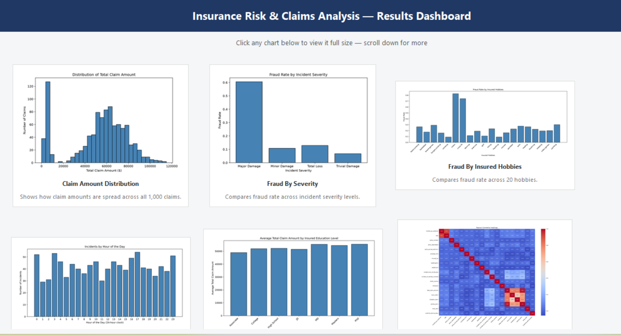

Testing
To confirm the project worked as intended, each stage was tested by checking that the code ran without errors and produced sensible, expected output. The table below summarises the key tests carried out.
# | Test | Expected Outcome | Actual Outcome | Pass/Fail
1 | Load raw dataset | Dataset loads with 1,000 rows and 40 columns | 1,000 rows, 40 columns loaded correctly
2 | Replace ? placeholders | All ? values converted to proper missing values | 178, 360, and 343 ? values found and replaced across three columns | Pass
3 | Fill missing categorical values | No missing values remain after cleaning | 0 missing values confirmed after cleaning | Pass
4 | Correct negative values | No customer_tenure_days value is below 0 | 1 negative row found and corrected to 0; minimum confirmed as 0 afterwards | Pass
5 | Create Chart | All 5 charts save to the outputs folder without error | All 5 charts generated and saved successfully | Pass
6 | Correlation matrix | Matrix correctly excludes non-numeric columns | Only the 19 numeric columns included; categorical columns correctly excluded | Pass
7 | Chi-square tests | p-values calculated for both severity and hobbies | p < 0.05 for both tests, correctly identified as significant | Pass
8 | T-test | p-value calculated comparing fraud vs. non-fraud claim amounts | comparing fraud vs. non-fraud claim amountsp = 1.95×10⁻⁷, correctly identified as significant | Pass
9 | Train/test split | 80/20 split with a similar fraud rate in both sets | 800/200 split; 24% vs. 27.5% fraud rate was close enough to confirm a fair split | Pass
10 | Logistic Regression training | Model trains without errors and produces an accuracy above chance level | 83.00% accuracy, no errors after scaling was applied | Pass
11 | Random Forest training | Model trains without errors and produces an accuracy above chance level | 79.00% accuracy, no errors | Pass
12 | GUI loads all charts | Dashboard displays every chart from the outputs folder as a thumbnail | All charts displayed; scrolling required to view all of them | Pass
13 | GUI click-to-enlarge | Clicking any thumbnail opens the correct full-size chart | Each thumbnail correctly opens its own chart, not the last one in the loop | Pass

Bugs Encountered
Several bugs were found and fixed during development. Rather than treating these as failures, they are documented here to show the debugging process and reasoning behind each fix.
- Negative customer tenure (02). One row showed an incident date before the policy start date, which is logically impossible. This was identified as a data error and corrected to 0, rather than deleting the row and losing the rest of its information.
- Mislabeled chart file. An earlier version of a standalone chart script (Chart_2_fraud_by_severity.py) contained the wrong chart's code entirely (the hour-of-day chart instead of the severity chart) and was missing the line that loads the dataset. This was identified when the file was reviewed for consistency and corrected.
- Duplicate chart file. An earlier version of the education-level chart script accidentally saved the same chart twice, under two different filenames (chart5_... and a stale chart6_...). This created a leftover file that was later picked up by the GUI dashboard as if it were a separate chart. The root script was fixed, and the other file was deleted.
- Logistic Regression convergence warning (05). The model initially failed to converge due to features being on very different numeric scales (e.g. claim amount in the tens of thousands vs. 0/1 encoded columns). This was fixed by applying StandardScaler, fitted only on the training data to avoid leaking test data into training.
- GUI popup opening off-screen (06). An earlier version of the dashboard only checked a chart's width when scaling it to fit the screen, which allowed tall charts (like the correlation heatmap) to open taller than the screen and push their title off the top of the display. This was fixed by checking both width and height and explicitly centring the popup window afterwards.
Evaluation
Success Criteria
Success Criteria | Target | Actual Result | Target Met?
Fraud prediction accuracy | 80% or higher | 83.00% (Logistic Regression) | Yes
Identify significant characteristics predicting fraud | Program identifies characteristics with a meaningful positive association with fraud | Incident severity (p < 0.05), insured hobbies (p < 0.05), and claim amount (p < 0.05) all confirmed as statistically significant | Yes
Handle large amounts of data | Process a large dataset efficiently | 1,000 claims, 40 original columns, processed and analysed without error across all six scripts | Yes
Intuitive graphical user interface | Charts, navigation, and descriptions for ease of use | Interactive dashboard built with clickable thumbnails, scrolling, and a brief description for every chart | Yes

Strengths
- The project's key finding is that incident severity, particularly "Major Damage," is strongly associated with fraud and was identified independently through three separate methods: visual EDA (Chart 2), formal statistical testing (chi-square, p < 0.001), and machine learning (feature importance). This consistency across methods gives genuine confidence in the finding, rather than it being a coincidence of one technique.
- The 83% accuracy achieved by Logistic Regression exceeded the 80% success criterion, and this result was reached without any data from the test set being used during training or scaling. Therefore, the result reflects genuine performance on unseen claims.
- The project includes a full data pipeline from raw data to a finished, interactive product (dashboard), rather than stopping at analysis alone.
- Bugs encountered during development (the negative tenure value, the mislabeled chart file, the convergence warning, the GUI scaling issue) were identified, understood, and fixed, rather than worked around.
Limitations
- The "chess" and "cross-fit" hobbies showed an unusually high fraud rate (83% and 74% respectively) compared to every other hobby (9–30%). While statistically significant, this is very unlikely to reflect a pattern and is more likely a quirk of how this dataset was generated or sampled. This is a good example of a model finding a pattern that is statistically real within the dataset but not necessarily meaningful outside it.
- The dataset contains only 1,000 claims from a single source. A larger, more varied dataset would ideally drawn from multiple real insurers which would give more confidence that the findings generalise beyond this specific dataset.
- Only two machine learning models were tested (Logistic Regression and Random Forest). Other approaches, such as Gradient Boosting or Support Vector Machines, were not explored and might perform differently.
Future Improvements
- Test additional models, such as Gradient Boosting, to see whether they outperform Logistic Regression.
- Test the model against a second, independent dataset to check whether the findings generalise beyond this one source.
- Extend the GUI to let a user upload their own claims data and receive a live fraud prediction, rather than only displaying pre-generated results.
Personal Reflection
This project took me through the full lifecycle of a data analysis project, from raw, messy data through to a finished, interactive product. Working with a real dataset meant encountering real problems that don't show up in a textbook example, such as inconsistent missing-value markers and a logically impossible date. Investigating and properly fixing these, rather than ignoring them, taught me that a "working" result and a "correct" result aren't always the same thing.
I also learned the value of using multiple methods to confirm a finding rather than trusting one chart or one test in isolation. The fact that severity showed up as significant in the EDA, the statistical testing, and the model's feature importance independently gave me far more confidence in that result than any single method would have.
I used AI tools during this project to help debug errors and speed up my learning of new concepts such as feature scaling and GUI development, but I made a point of understanding and verifying every fix myself before accepting it, rather than copying code I couldn't explain. I believe this is a responsible and realistic way to use AI as a developing analyst, rather than avoiding it entirely or relying on it uncritically.

References
References
Insuranceopedia (2026) Insurance risk: definition, how it works & why it matters. Available at: https://www.insuranceopedia.com/definition/2430/insurance-risk (Accessed: 20 September 2026).
GeeksforGeeks (2024) Insurance: meaning, definitions and functions. Available at: https://www.geeksforgeeks.org/business-studies/what-is-insurance-functions-of-insurance/ (Accessed: 20 September 2026).
GeeksforGeeks (2026) Data cleaning. Available at: https://www.geeksforgeeks.org/data-analysis/data-cleaning-introduction/ (Accessed: 20 September 2026).
StudySmarter (2024) Claim frequency: definition & analysis. Available at: https://www.studysmarter.co.uk/explanations/business-studies/actuarial-science-in-business/claim-frequency/ (Accessed: 20 September 2026).
BBC Bitesize (no date) Mean, median, mode and range. Available at: https://www.bbc.co.uk/bitesize/articles/z3t4g7h (Accessed: 20 September 2026).
Aqqad, A. (2023) insurance_claims [Dataset]. Mendeley Data, V2. doi: 10.17632/992mh7dk9y.2.

